# Concept document for “On The Clock” (working title)

## First screen

- form at the start that asks whether you wish to use mobile style or desktop style movement (nipple movement/key input movement, interaction through a UI button/key input)

## Screen elements

## 

- A rotating clock that can be dragged by the mouse (nipple?)

- a square canvas on which the player can move

- elements that react to the state of this clock

- text boxes underneath the canvas, you can select dialogue options through clicking them.

- animations for the player character, but otherwise it can be unanimated.

- UI elements to control the character if user selected the mobile version in the form

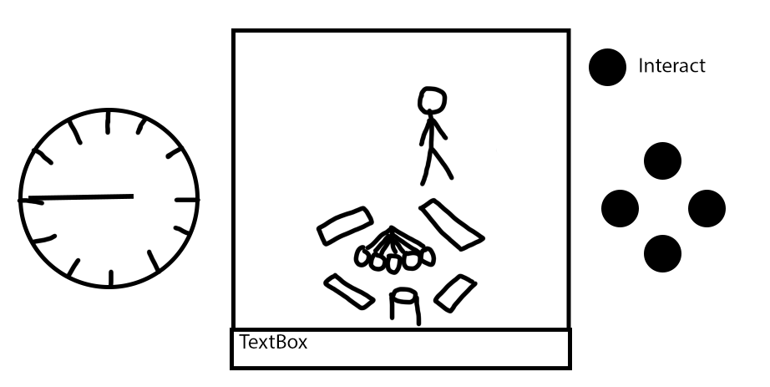

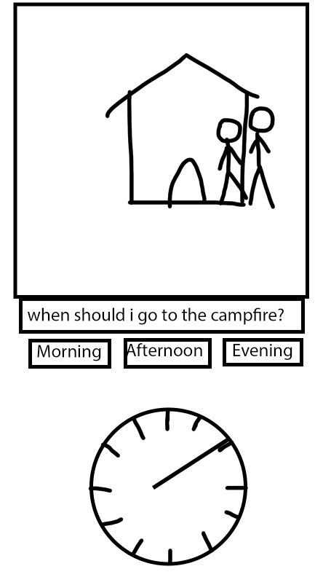

## Gameplay

- a map of 9 tiles of canvas screens that are linked together, so the player can walk between them (screen index of 0 – 8). These map tiles feature houses, NPCs, and other objects.

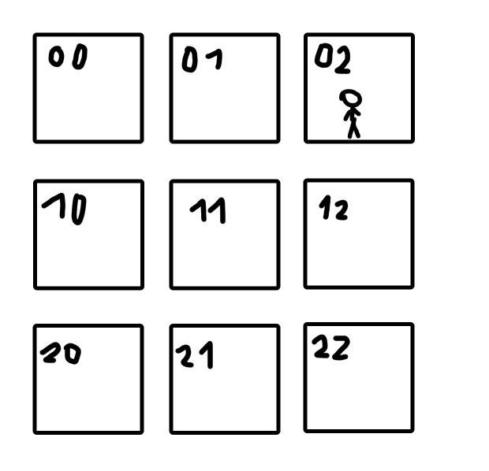

- you can interact with NPCs, which will show you some dialogue underneath the Canvas.

- the Clock represents time of day. Each day is separated into 4 parts – morning, (around) noon, afternoon, evening.

- Rotating the clock will change where the NPCs are – each NPC has a simple schedule, and will be in different times according to what day phase it is.

- Overall goal of the game is to sync up the schedules of your friends to gather around a campfire.

- slight puzzle: finding a way to affect the schedules of your friends. Finding out which phase of the day they can all be free.

### Example:

One of the friends can be found working at a restaurant, by default they are busy at lunch time, because that’s when rush hour is. In the world, you can find a sign that advertises this restaurant’s lunches. You get the option to change this sign to advertise dinner, afternoon tea, or breakfast, which will change when the restaurant is busy. When the friend isn’t busy at the moment, you can come up to them and tell them to meet you at the campfire right away.

## Assets

Since this is a non-commercial product, I will be using freeware assets found on itch.io. Some preliminary options:

[Cozy People Asset Pack by shubibubi (itch.io)](https://shubibubi.itch.io/cozy-people)

[SmallBurg - Village Pack by almostApixel (itch.io)](https://almostapixel.itch.io/small-burg-village-pack)